**CS550 Advanced Operating Systems**​

**Programming Assignment 3**

​

**Evaluation**

**Experiment-2**

**Amazon Aws**

**submitted by:**

Chiranjeevi Ankamreddy

A20359837

The assignment carries out Evaluation of the Decentralized Indexing server and Peer server on 10 operations runs on amazon aws.

I’ve evaluated the time taken to **Register ,Search** operations on a Indexing server a single node ,two nodes ,four nodes and eight running concurrently over **10** operations.

And Evaluated the time taken to **Obtain** Files on a Peer server a single node ,two nodes ,four nodes and eight running concurrently over 10 operations. And File Size is **100MB.**

**1. Register:**

***single node:*** ​The time taken to Register 10 Files on a single node at is 54**millisecs**​.

Two  ***nodes :*** ​ The time taken to Register 10 Files on each of 2 nodes is :

node 1 ­ 61 millisecs

node 2 ­ 74millisecs

Average time taken by a node to Register 10 Files is : /2

=​ **68 millisecs**

***Four nodes :*** ​ The time taken to Register 10 Files on each of four nodes is :

node 1 ­ 72 millisecs

node 2 ­ 85 millisecs

node 3- 82 millisecs

node 4- 88 millisecs

Average time taken by a node to Register 10 Files is:/4= 65 **millisecs**

***Eight nodes :*** ​ The time taken to Register 10 Files on each of Eight nodes is :

node 1 ­ 66millisecs

node 2 ­ 71 millisecs

node 3- 82 millisecs

node 4 ­ 64millisecs

node 5 ­ 78 millisecs

node 6- 89 millisecs

node 7 ­ 96 millisecs

node 8 ­ 104millisecs

Average time taken by a node to Register 10 Files is: 81  **millisecs**

**Average time taken for a single node per Register 10 Files 54: millisecs**

**Average time taken for two concurrent nodes per Register 10 Files : 68 millisecs**

**Average time taken for four concurrent nodes per Register 10 Files : 65millisecs**

**Average time taken for a eight concurrent nodes per Register 10 Files : 81millisecs**

**PLOT FOR REGISTER :**

**X­axis : nodes**

**Y­Axis : time (millisecs)**

**C:\Users\Chiru\Downloads\Untitled Diagram (1).png**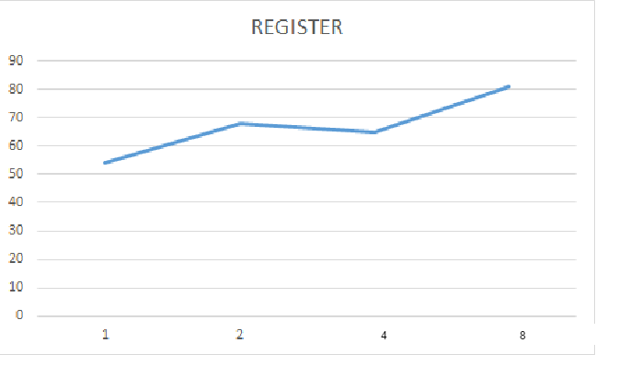

**C:\Users\Chiru\Downloads\Untitled Diagram.png**

**2. SEARCH :**

***single node:*** ​The time taken to Search 10 Files on a single node at is 63**millisecs**​.

Two  ***nodes :*** ​ time taken to Search 10 Files on each of 2 nodes is :

node 1 ­71 millisecs

node 2 ­ 77 millisecs

Average time taken by a node to Search 10 Files is : /2

=​ **74millisecs**

***Four nodes :*** ​Time taken to Search 10 Files on each of four nodes is :

node 1 ­ 54 millisecs

node 2 -69 millisecs

node 3- 82millisecs

node 4- 86 millisecs

Average time taken by a node to make Search 10 Files is 75.5  **millisecs**

***Eight nodes :*** ​Time taken to Search 10 Files on each of Eight nodes is :

node 1 ­ 74 millisecs

node 2 ­79 millisecs

node 3- 68 millisecs

node 4 ­ 84 millisecs

node 5 ­ 96millisecs

node 6- 92 millisecs

node 7 ­104 millisecs

node 8 ­ 87 millisecs

Average time taken by a node to Search 10 Files is 86 **millisecs**

**Average time taken for a single nodes per 10 Search Files : 54millisecs**

**Average time taken for two concurrent nodes per 10 Search Files : 73 millisecs**

**Average time taken for four concurrent nodes per 10 Search Files : 75millisecs**

**Average time taken for a eight concurrent nodes per 10 Search Files : 86millisecs**

**PLOT FOR SEARCH:**

**X­axis : nodes**

**Y­axis : time (millisecs)**

C:\Users\Chiru\Downloads\Untitled Diagram (1).png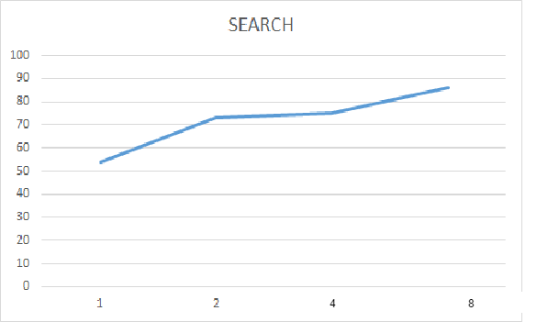

C:\Users\Chiru\Downloads\Untitled Diagram.png

**3. Obtain:**

***single node:*** ​The time taken to obtain 10 Files at a single node at is ​ **296 secs**.​

***two nodes :*** ​ Time taken to obtain 10 Files at 2 nodes concurrently i.e., 200k files on both nodes is :

node 1 ­264secs

node 2 ­ 258secs

Average time taken by a node to obtain 10 Files is : /2

=​ **261secs**

***Four nodes :*** ​Time taken to obtain 10 Files on each of four nodes is :

node 1 ­ 274secs

node 2 ­ 297secs

node 3- 315secs

node 4- 324secs

Average time taken by a node to obtain 10 Files is :/4= 302  **Secs**

***Eight nodes :*** ​Time taken to obtain 10 Files on each of Eight nodes is :

node 1 ­ 288secs

node 2 ­ 354secs

node 3- 324secs

node 4 ­ 307secs

node 5 ­ 344secs

node 6- 321secs

node 7 ­ 364secs

node 8 ­337secs

Average time taken by a node to obtain 10 Files is /8=  **329secs**

**Average time taken for a single node to obtain 10 Files : 296secs**

**Average time taken for two concurrent nodes to obtain 10 Files : 261secs**

**Average time taken for four concurrent nodes to obtain 10 Files : 302secs**

**Average time taken for a eight concurrent nodes to obtain 10 Files: 329Secs**

**PLOT FOR OBTAIN:**

**X­axis : nodes**

**Y­axis : time(secs)**

**C:\Users\Chiru\Downloads\Untitled Diagram (1).png**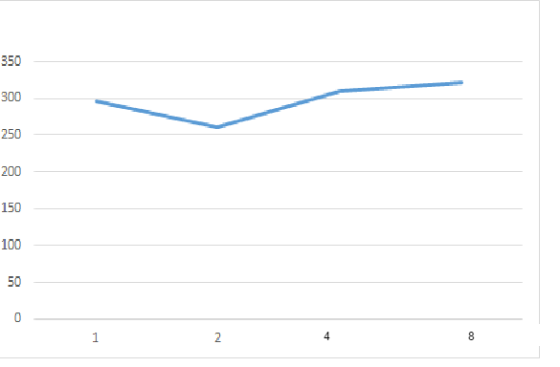

C:\Users\Chiru\Downloads\Untitled Diagram.png

**Conclusion:**

Here,we have evaluated register,search and obtain the files of size 100Mb.and it runs on Amazon aws cloud over 10 fileS on each server.As the number of nodes increases,time to register will increases in DIS, and search is increases initially because IN DHT, it runs on core uses maximum speed. And obtaining file is also uses maximum core speed.